Revision 4: Algorithms and programming - Student booklet
Y11 - Cambridge IGCSE Computer Science 0478 | Practice exam revision
Name: _______________________________ | Date: _____________

- Learn sections are your revision notes: read them carefully, then do the task straight after.
- Task 1 is a closed-book recall test - do it from memory first.
- Questions with a paper reference are real Cambridge 0478 questions. Your teacher will share the answers.
Task 1 Recall test on Revision 3 (closed book) [10 marks]
# | Question | Answer
1 | Give the three characteristics of a robot.
2 | Name the device in an automated system that switches something on or off.
3 | Name the component of an expert system that applies the rules.
4 | What is machine learning?
5 | Which gate outputs 1 only when both inputs are 0?
6 | Which gate outputs 1 when the inputs are different?
7 | Complete: NOT 1 = ?
8 | How many rows does a truth table with three inputs have?
9 | What is the maximum number of inputs a gate may have in an exam circuit?
10 | Write the output of 1 NAND 1.
Learn Program development
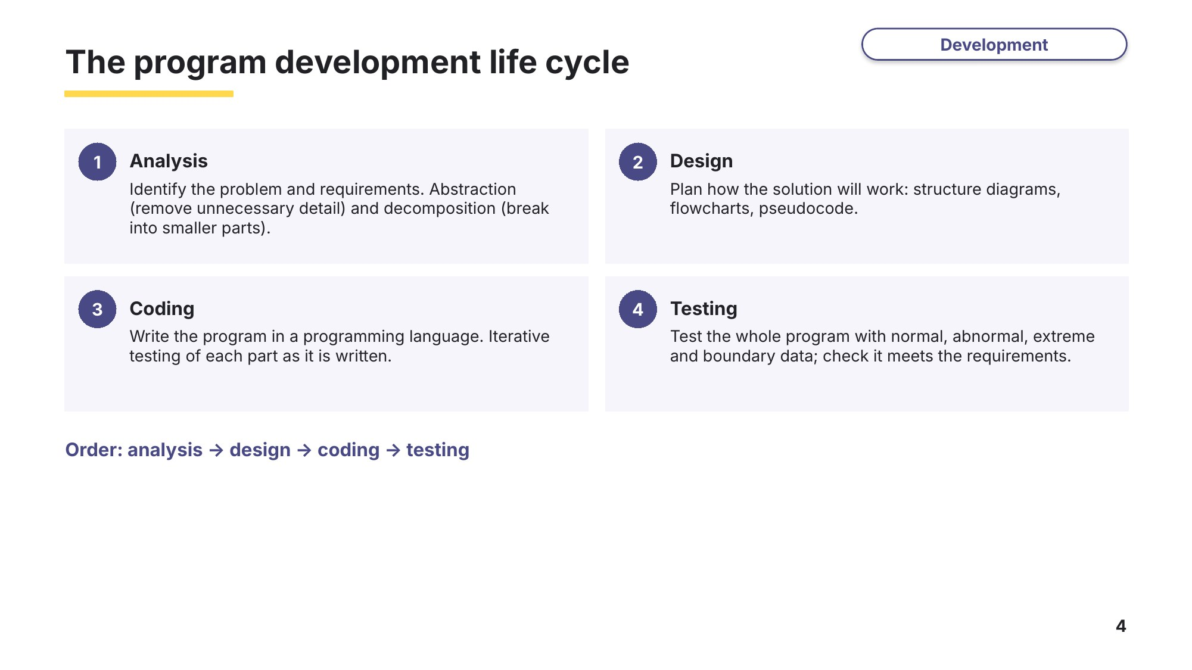
Slide 4 - The program development life cycle
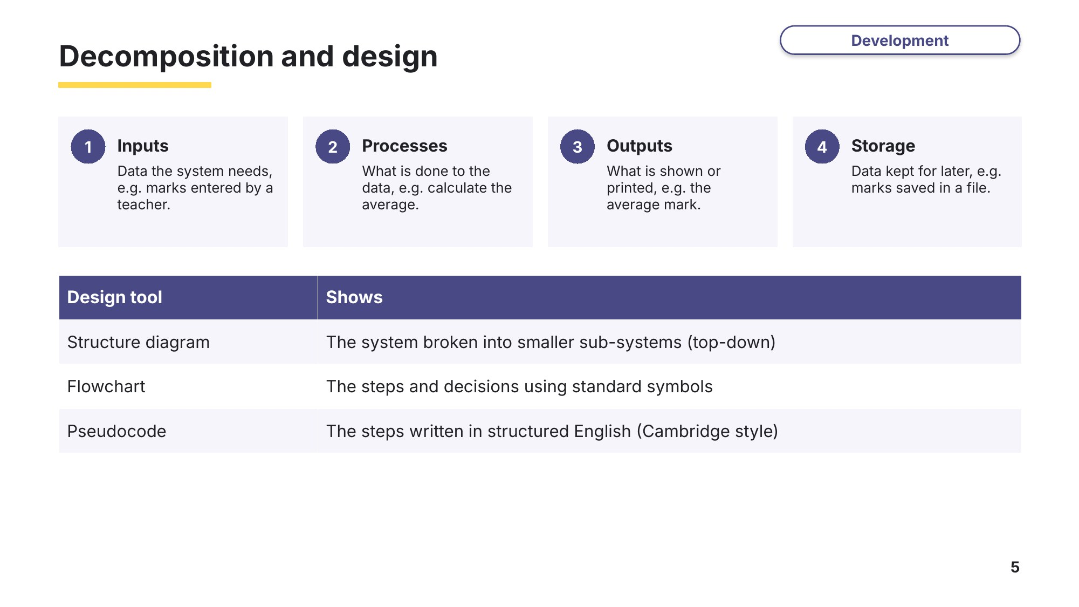
Slide 5 - Decomposition and design
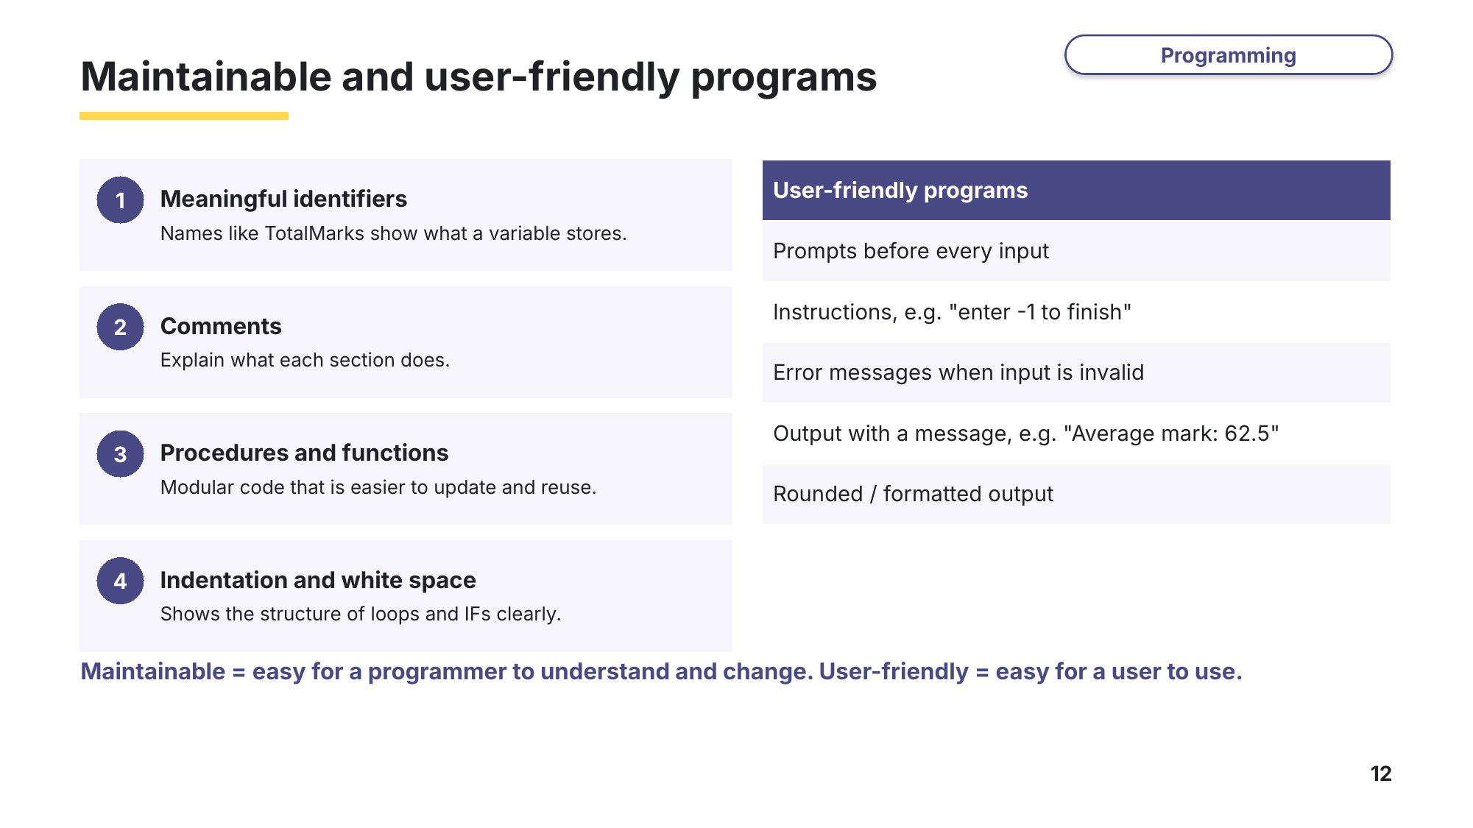
Slide 12 - Maintainable and user-friendly programs
Task 2 Program development life cycle and maintainable programs [17 marks]
2A Analysis and other stages
0478/21 October/November 2023 Q5
The first stage of the program development life cycle is analysis. Two of the tasks in analysis are abstraction and decomposition.
(a) Describe what is meant by abstraction. [2]

(b) Identify three of the component parts when a problem has been decomposed at the analysis stage. [3]
1

2

3

(c) Identify and describe one other stage of the program development life cycle. [2]

2B Two other stages
0478/23 October/November 2024 Q5
One stage of the program development life cycle is the analysis stage.
Identify and describe two other stages of the program development life cycle. [6]
Stage ……………………………………
Description

Stage ……………………………………
Description

2C Maintainable programs
0478/21 May/June 2023 Q6
State two features that should be included to create a maintainable program. Give a reason why each feature should be used. [4]
1

2

Learn Data checks
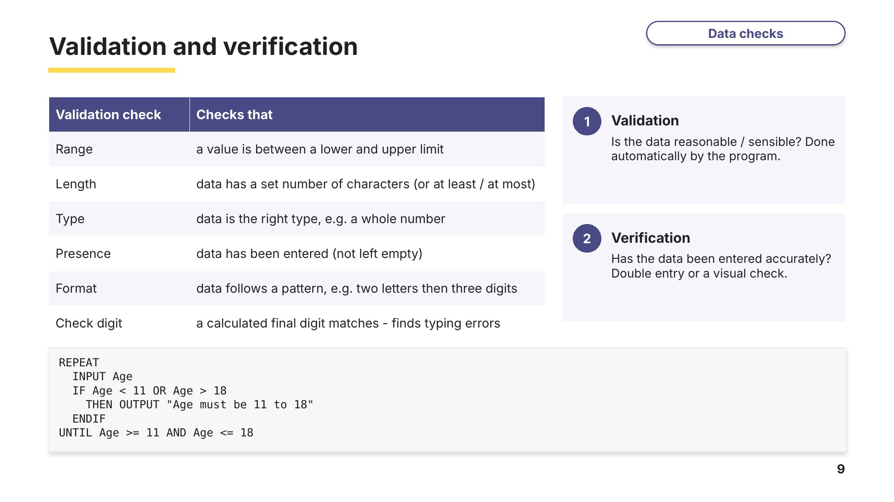
Slide 9 - Validation and verification
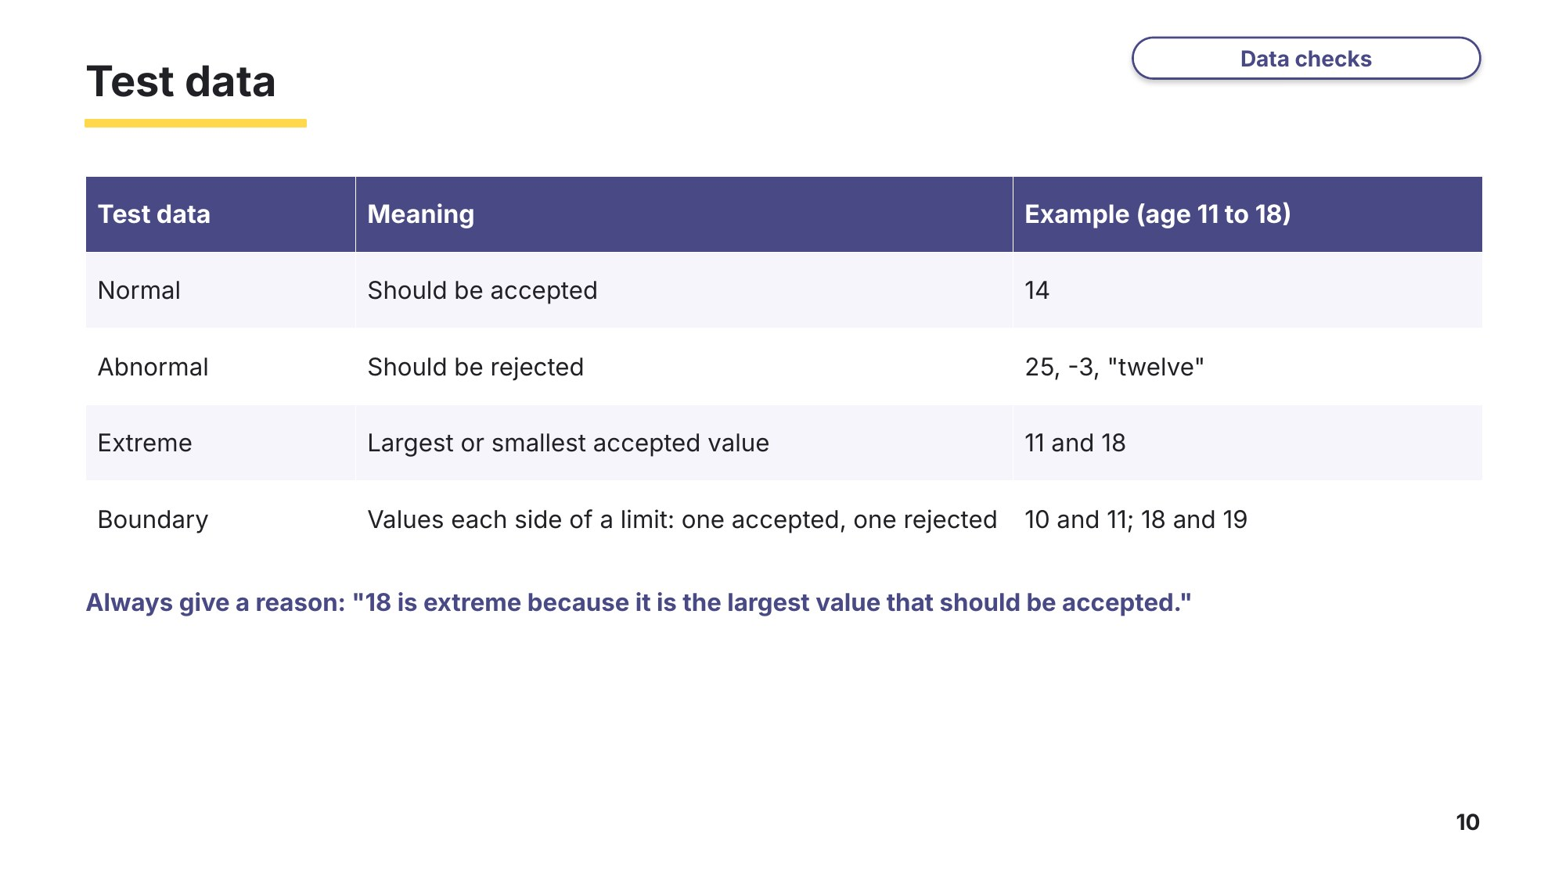
Slide 10 - Test data
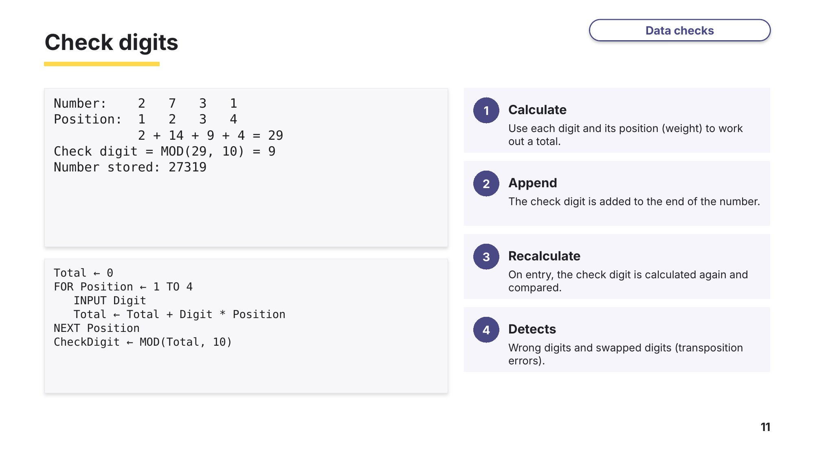
Slide 11 - Check digits
Task 3 Validation, verification and test data [17 marks]
3A Verification
0478/23 May/June 2023 Q4
(a) Explain why verification checks are used when data is input. [2]

(b) Give two types of verification check and state how each one can be used. [4]
Verification check 1 …………………………………… Use

Verification check 2 …………………………………… Use

3B Range and length checks
0478/23 May/June 2025 Q4
(a) An input must be an integer between 10 and 95, inclusive.
(i) State the type of validation check to test if the input meets this requirement. [1]

(ii) Suggest suitable abnormal and extreme test data for an integer between 10 and 95 inclusive, and give a reason for each of your choices. [4]
Abnormal test data ………………… Reason

Extreme test data ………………… Reason

(b) A password system requires all new passwords to contain at least 12 characters.
(i) State the type of validation check to test that the password meets this requirement. [1]

(ii) Write the pseudocode to allow a new password to be entered and to ensure that it contains at least 12 characters. The password is re-input until it meets this requirement. Use an appropriate error message for inputs that do not meet the requirement. You do not need to declare any variables for this algorithm. [5]
Learn Programming
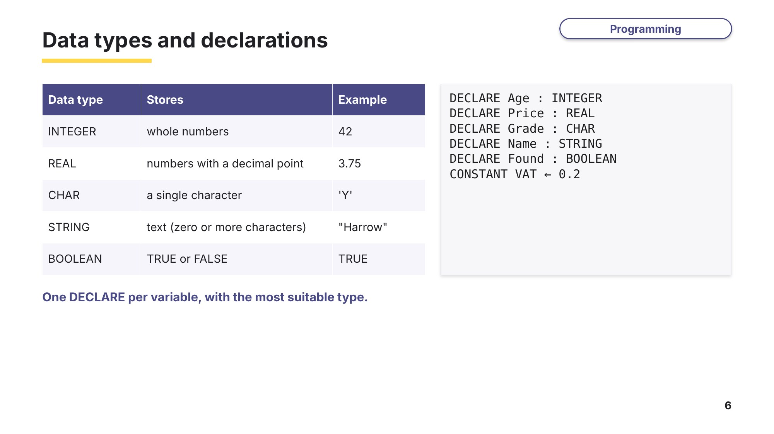
Slide 6 - Data types and declarations
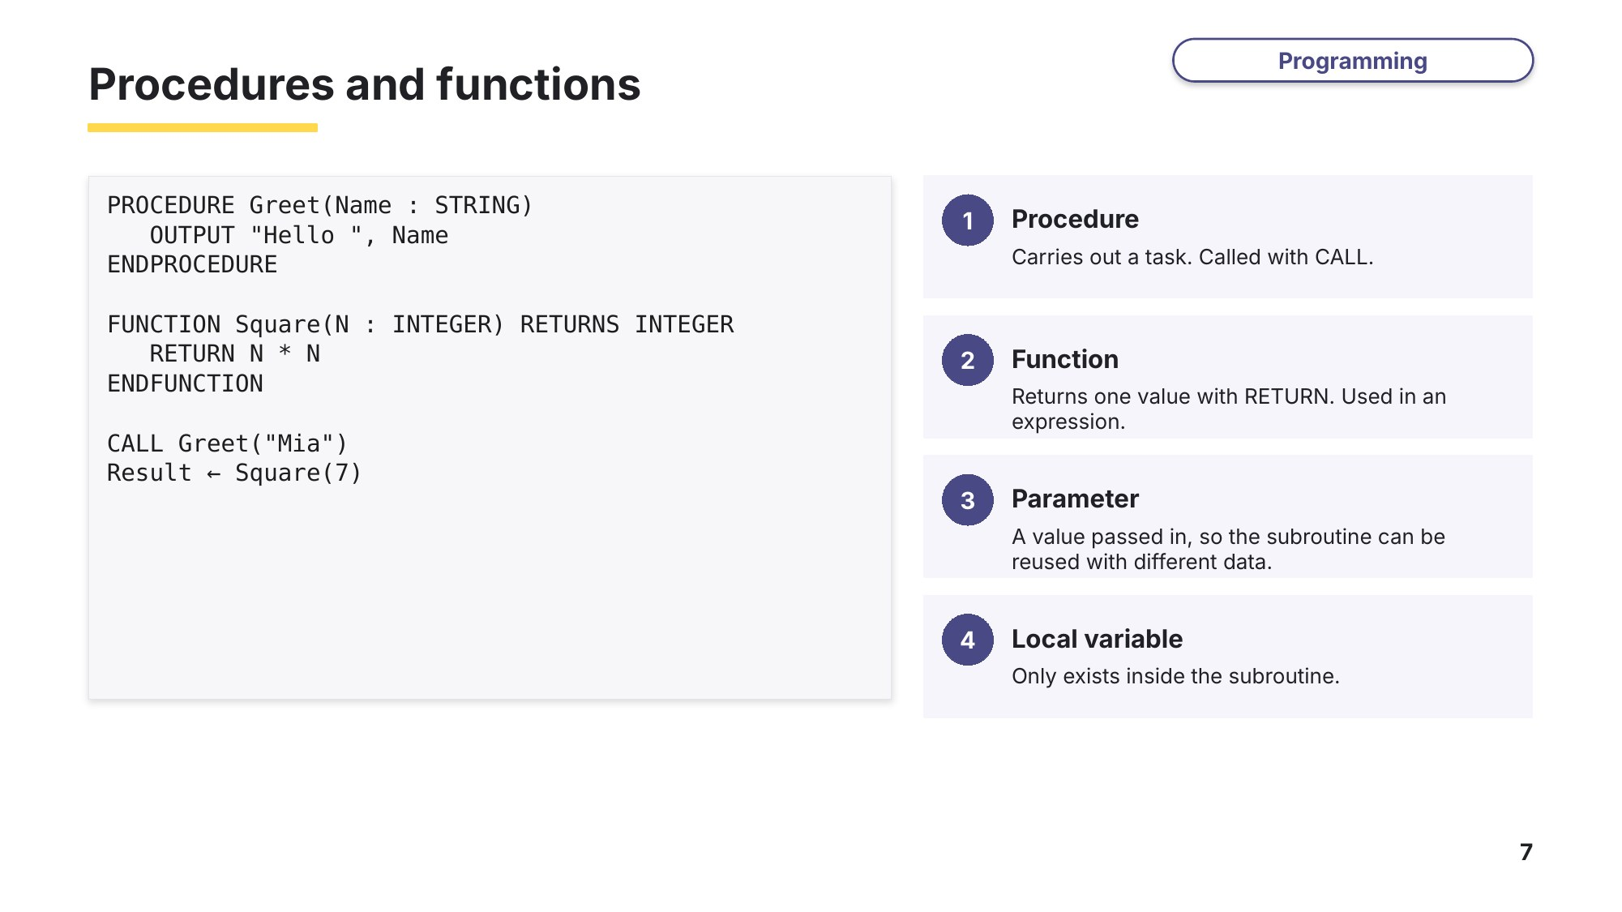
Slide 7 - Procedures and functions
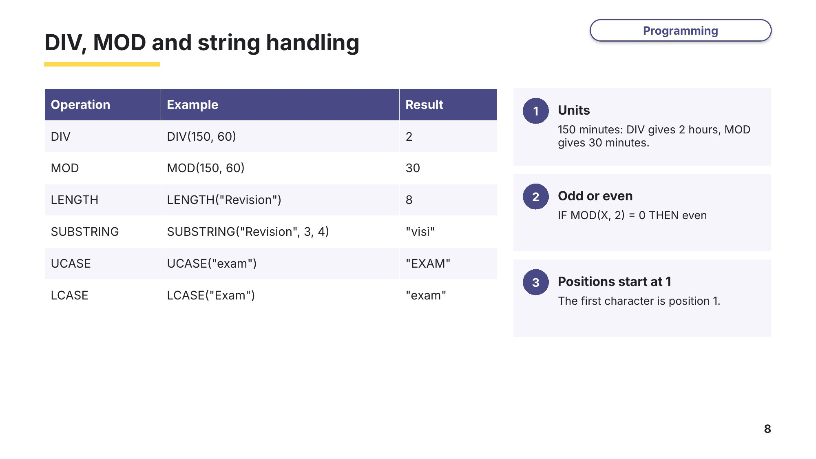
Slide 8 - DIV, MOD and string handling
Task 4 Procedures, functions, DIV/MOD and strings [21 marks]
4A Declaring and writing a function
0478/21 May/June 2025 Q9
The variables A and B are used in a program. A holds a whole number and B holds text.
(a) Write pseudocode statements to declare the variables A and B. [2]

(b) The function Odds(X) returns ‘Odd’ if the value of X is an odd number and returns ‘Even’ if the value of X is an even number. Write pseudocode statements to: define the function; call the function using parameter A and store the return item in variable B. [6]
Function definition
Function call

4B Why use procedures and parameters?
0478/22 October/November 2023 Q8
Explain why a programmer would use procedures and parameters when writing a program. [4]

4C String handling
0478/22 October/November 2023 Q7
The string operation SUBSTRING(Quote, Start, Number) returns a string from Quote beginning at position Start that is Number characters long. The first character in Quote is in position 1.
Write pseudocode statements to: store the string "Learning Never Exhausts The Mind" in Quote; extract and display the words "The Mind" from the string; output the original string in lower case. [5]
4D DIV and MOD (exam-style)
The procedure WeeksDays(TotalDays) takes a whole number of days as a parameter. It converts the number of days into weeks and days and outputs the result, for example 17 days is output as 2 weeks and 3 days. Write this procedure in pseudocode. [4]
Learn Finding errors and tracing
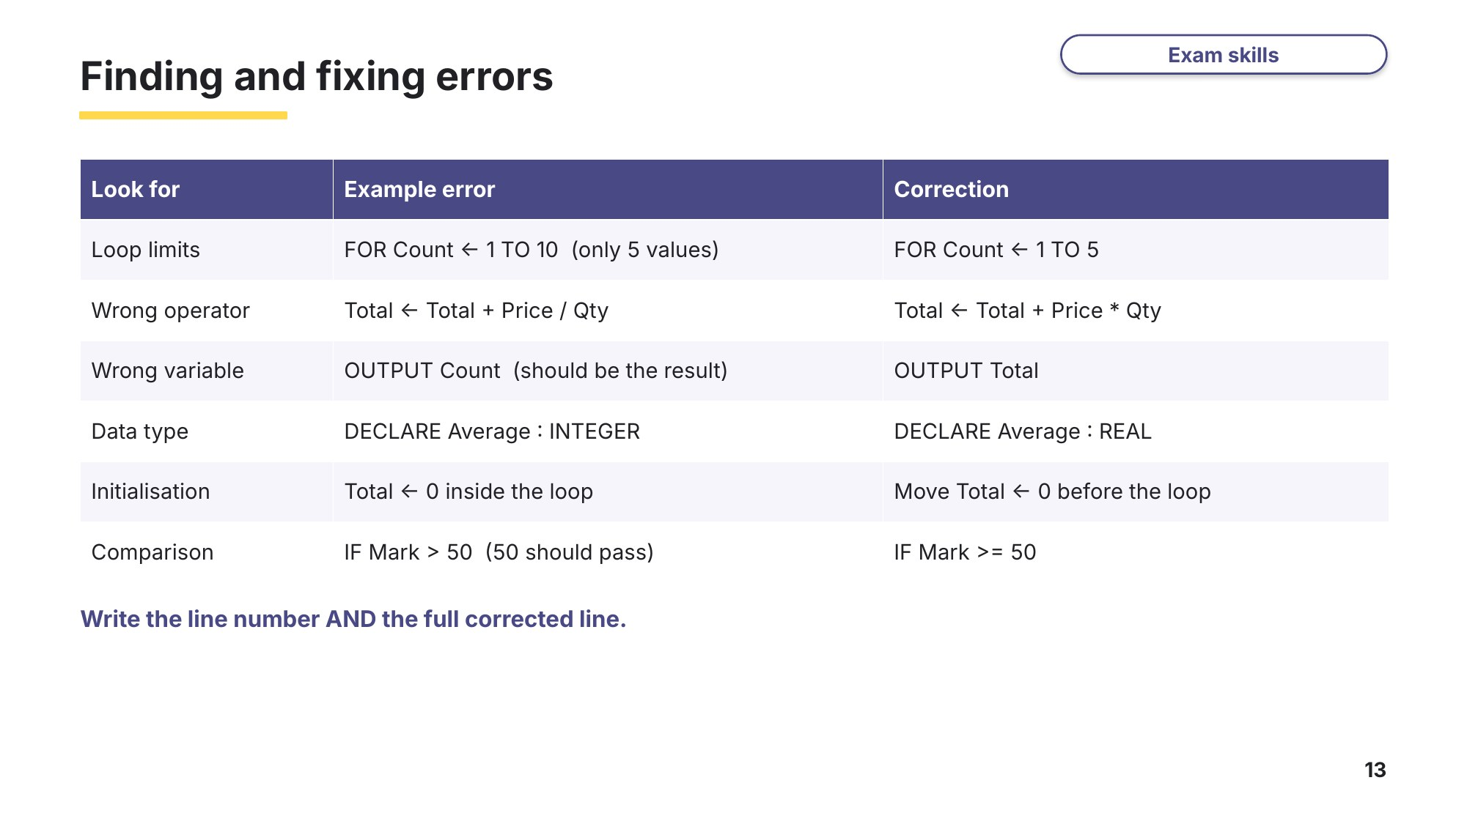
Slide 13 - Finding and fixing errors
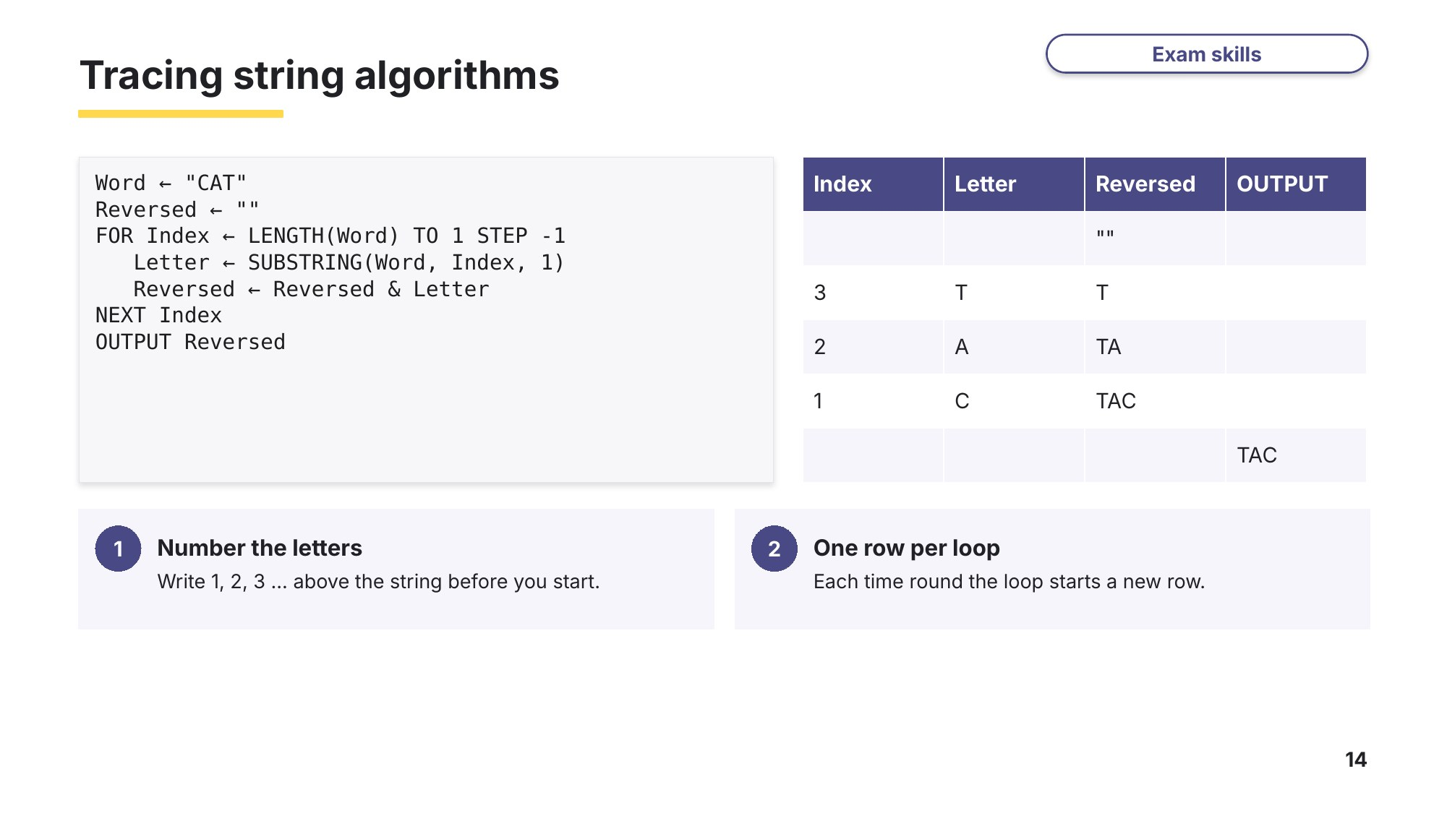
Slide 14 - Tracing string algorithms
Task 5 Tracing and correcting algorithms [20 marks]
5A Tracing a string algorithm
0478/22 May/June 2025 Q6
This pseudocode is an algorithm.
DECLARE Word : STRING
DECLARE V1 : INTEGER
DECLARE V2 : INTEGER
DECLARE Number : INTEGER
DECLARE Index : INTEGER
DECLARE L1 : CHAR
DECLARE L2 : CHAR
DECLARE Continue : BOOLEAN
INPUT Number
FOR Index ← 1 TO Number
INPUT Word
Continue ← TRUE
V1 ← 1
V2 ← LENGTH(Word)
WHILE Continue = TRUE AND V1 < V2 DO
L1 ← SUBSTRING(Word, V1, 1)
L2 ← SUBSTRING(Word, V2, 1)
IF L1 <> L2
THEN
Continue ← FALSE
ELSE
V1 ← V1 + 1
V2 ← V2 – 1
ENDIF
ENDWHILE
IF Continue = TRUE
THEN
OUTPUT "Successful"
ELSE
OUTPUT "NOT successful"
ENDIF
NEXT Index
(a) Complete the trace table for the algorithm, using the input data: 2, RACECAR, TREAT [6]
Number | Index | Word | Continue | V1 | V2 | L1 | L2 | OUTPUT
(b) State the purpose of the algorithm. [1]

(c) Explain how the algorithm knows when all the letters in the word have been checked so that it can stop checking. [3]

5B Check digit algorithm with errors
0478/22 May/June 2023 Q7
An algorithm has been written in pseudocode to calculate a check digit for a four-digit number. The algorithm then outputs the five-digit number including the check digit. The algorithm stops when –1 is input as the fourth digit.
01 Flag ← FALSE
02 REPEAT
03 Total ← 0
04 FOR Counter ← 1 TO 4
05 OUTPUT "Enter a digit ", Counter
06 INPUT Number[Counter]
07 Total ← Total + Number * Counter
08 IF Number[Counter] = 0
09 THEN
10 Flag ← TRUE
11 ENDIF
12 NEXT Counter
13 IF NOT Flag
14 THEN
15 Number[5] ← MOD(Total, 10)
16 FOR Counter ← 0 TO 5
17 OUTPUT Number[Counter]
18 NEXT
19 ENDIF
20 UNTIL Flag
(a) Give the line number(s) for the statements showing: [3]
Totalling
Count-controlled loop
Post-condition loop
(b) Identify the three errors in the pseudocode and suggest a correction for each error. [3]
Error 1 ……………………………………………………………………
Correction ……………………………………………………………………
Error 2 ……………………………………………………………………
Correction ……………………………………………………………………
Error 3 ……………………………………………………………………
Correction ……………………………………………………………………
(c) The algorithm does not check that each input is a single digit. Identify the place in the algorithm where this check should occur. Write pseudocode for this check. Your pseudocode must make sure that the input is a single digit and checks for –1. [4]
Place in algorithm ……………………………………
Learn Flowcharts and pseudocode
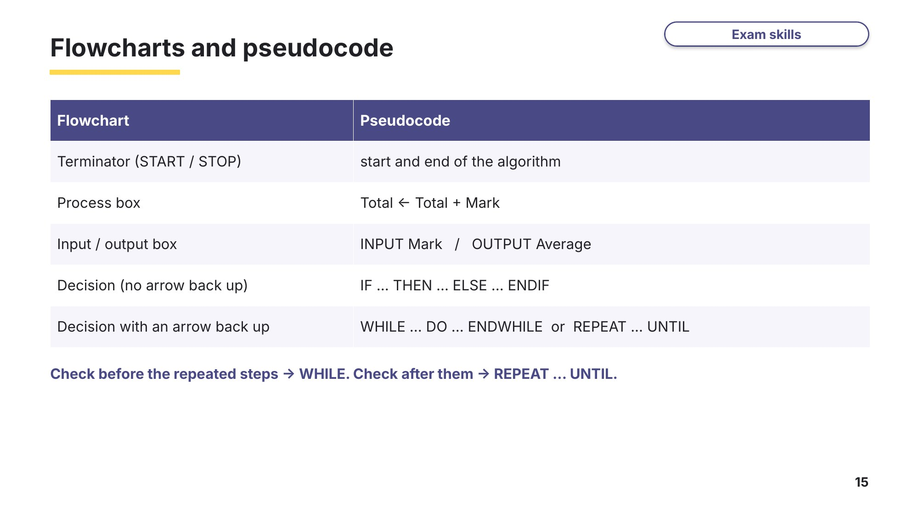
Slide 15 - Flowcharts and pseudocode
Task 6 Flowcharts and user-friendly programs (exam-style) [12 marks]
This flowchart represents an algorithm.
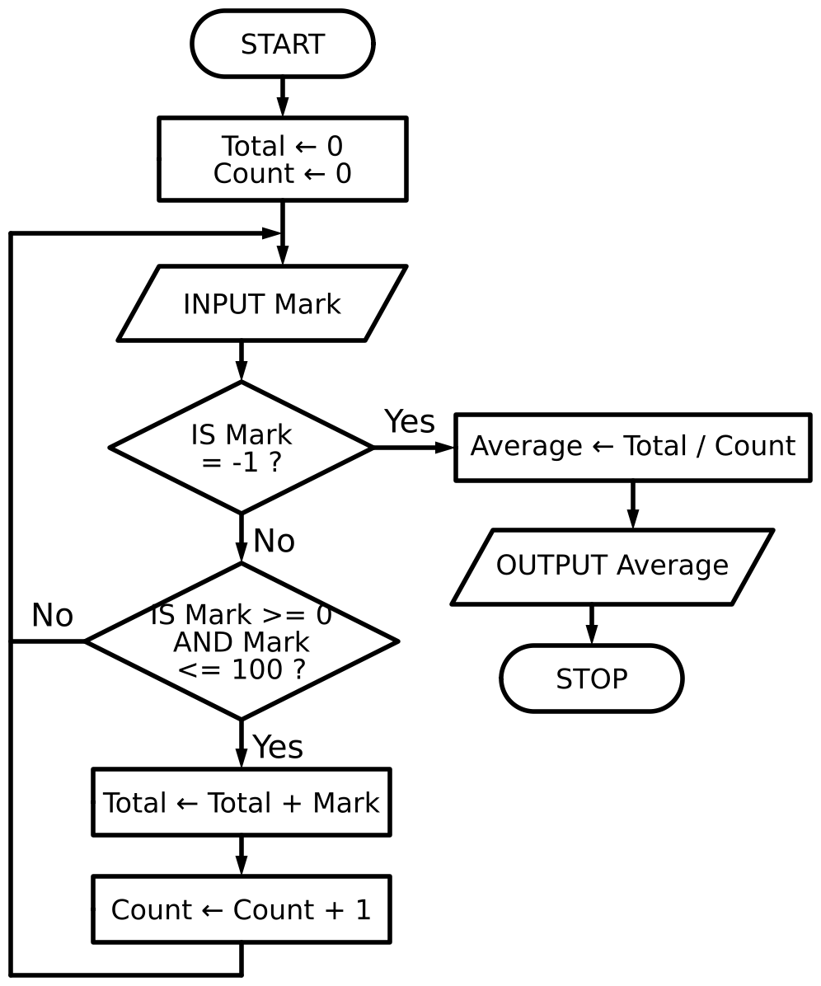
(a) Complete the trace table for the input data: 45, 120, 80, –1 [3]
Mark | Total | Count | Average | OUTPUT
(b) Describe the purpose of the algorithm. [2]

(c) Identify three improvements that could be made to the algorithm to make it more user-friendly. [3]
1

2

3

(d) Write the algorithm in pseudocode. [4]
Task 7 Extension: a type check algorithm [7 marks]
7A Presence and type checks
0478/22 February/March 2025 Q4
(a) A presence check is a type of validation check. State the purpose of a presence check. [1]

(b) A value input into a computer system must be an integer.
(i) Identify the validation check used to test whether the value input meets this requirement. [1]

(ii) Write the pseudocode for an algorithm to allow a number to be input into an appropriate variable and check whether the number is an integer. If the number is an integer, it is accepted. If the number is not an integer, an error message is output. Re-input of the number is required until a valid number is input. [5]

